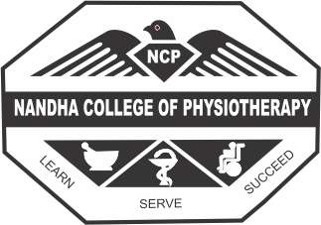

NANDHA COLLEGE OF PHYSIOTHERAPY
Affiliated to the TN.DR.M.G.R. Medical University, Chennai
Koorapalayam, Erode 638052, Tamil Nadu, India

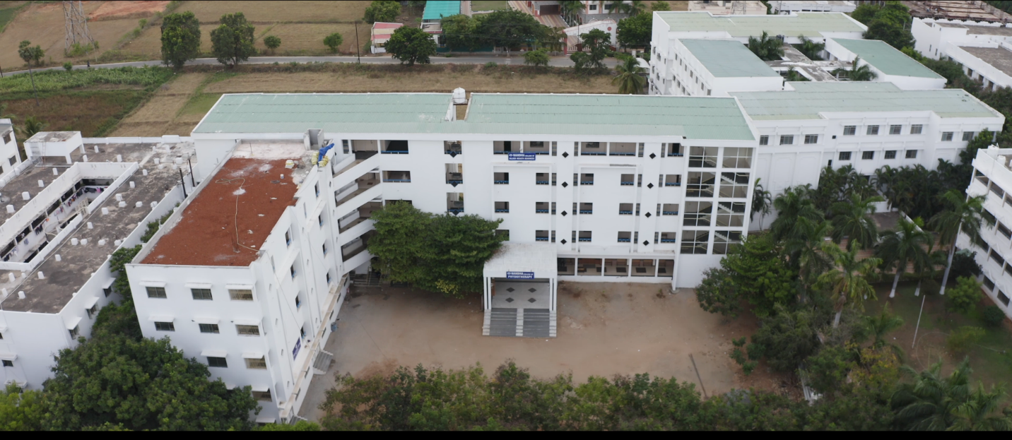

GREEN CAMPUS AND ENVIRONMENT POLICY

Green Campus and Environmental Policy:
Green Practice in Campus:
Institute’s primary concern is about green practices for sustainable environment and inculcating empathy towards environment among students and staff. NCPT has implemented digitization by promoting the usage of less quantity of paper in academic and administrative processes by effective waste management. Students are sensitized about green practices through the orientation programs, environmental studies class, poster competitions, practical assignments, celebrations like world Water day, Environmental day, etc.
The institute pays much attention on green practices by the following ways
- Restricted Entry of Automobiles
- Pedestrian friendly path ways
- Plastic free campus
- Paperless office
- Green landscaping with trees and plants
- Energy Conservation.
Restricted Entry of Automobiles
- Faculty and students are advised to park their vehicles in the parking space provided for them and are not entertained to park on the roads in the campus.
- Faculty and students commuting by two wheelers are instructed to wear helmets to ensure safety.
- Security guards are allotted duties to ensure not to parking vehicles in no parking areas.
- Placards are being placed in no parking areas.
- The Management provides transport facilities to both faculty and students. It also supports the faculty and students to use public transport or their own vehicle.
Pedestrian friendly roads
- NCPT has taken special effort towards the construction and maintenance of the internal roads for pollution free campus.
- Faculty and the students are advised to use pedestrian friendly pathways for convenience and safety.
Plastic Free Campus
- Awareness program on Environment pollution and the effective ways to protect it
is conducted by the students to the public.
- A’No Plastic’ awareness campaign is conducted by NSS at NCPT to share the hazards of indiscriminate use of plastic. Being conscious towards the environment, Institute instructs the students to minimize the use of plastic.
- Faculty and student volunteers frequently monitor the dining hall, washing area, canteen and other common places to avoid the use of plastics.
- Students are advised to use paper plates, and jute bags.
- Hazardous wastes are identified and disposed appropriately.
Paperless Office
NCPT supports the Government of India’s Digital India Program, which aims to transform India into a digitally empowered nation. NCPT believes in going digital in every possible way and reduces the use of papers in academic and administrative processes. Reuse of papers for writing and printing is recommended in all departments. E-Notice practice is being followed by departments to disseminate information. Reformation Software is in use for hall booking, addressing the issues etc.
Green landscaping with Trees and Plants
- Much attention was paid not to cut down the trees in campus while constructing buildings. Most of the buildings are constructed without demolishing trees in the campus. Thus the campus holds more than 75% of green cover.
- Eco –landscaping is designed and maintained in such manner that it saves time, money and energy. It contributes in reducing air, soil and water pollution.
- College has organized various activities on green practices for the benefit of society. Education on Environmental science is a part of the program to create awareness among students on environment and sustainability.
Energy Conservation
- The campus is beautifully landscaped in a lush green stretch of land and is free from air and noise pollution.
- Guidelines are provided to the students and faculty in the campus regarding conservation of the environment and saving energy.
- Rule of turning off the computers when not in use and turning off all the electrical equipments before leaving the class room/ lab/ campus is adopted to save energy. Solar water heaters are used in the hostels. It is recommended to replace all the fluorescent lamps in the campus with LED lamps.
Waste water Recycling:
- Recycled water from the canteen and other cooking areas in the campus is used for watering plants.
POLICY FOR PLASTIC BAN IN CAMPUS
- To ban disposable plastics in canteens, campus premises, hostels etc.
- To mandate all the staffs and students members to avoid bringing non-bio-degradable plastic items to the campus.
- To avoid the use of plastic water bottles, bags and to encourage the use of alternative sources like cloth bags, paper bags etc.,
- To keep sign boards at various places to create wide publicity to ban the use of polythene bags in the campus.

